CPS 510 - Database Systems I
Group 8
Assignment - 4_1

Amartya Chowdhury, 501153217
Mehrin Afroz Eshana, 501147157
Mohamad Al Walied Hasan Nafis, 501241332

INSERT Statements:

Statement 1:
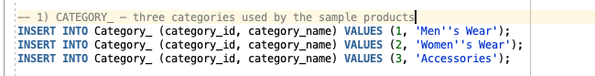
Result for Statement 1:
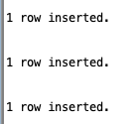

Statement 2:
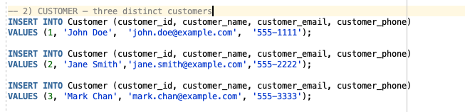
Result for Statement 2:


Statement 3:
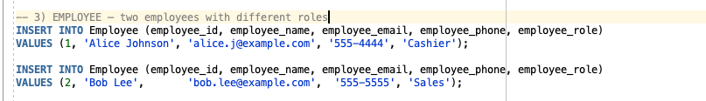
Result from statement 3:
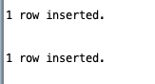

Statement 4:
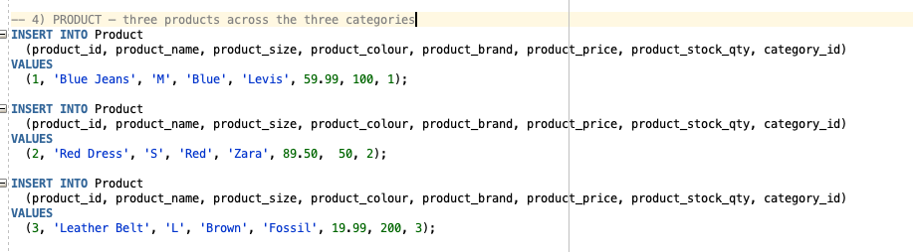
Result from Statement 4:


Statement 5:
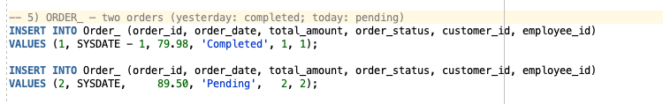
Result from Statement 5:


Statement 6:
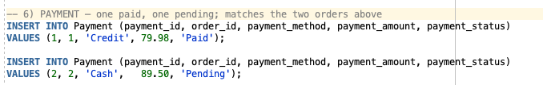
Result from Statement 6:


Statement 7:
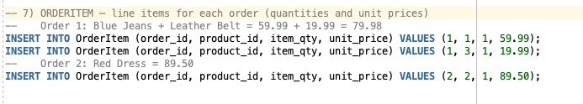
Result from Statement 7:


QUERIES:

Query 1:
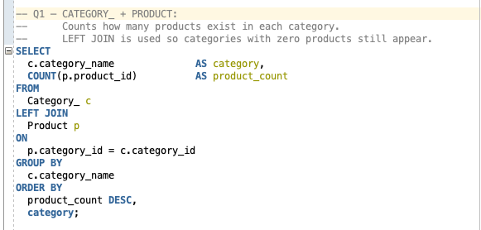
Result of Query 1:

Query 2:
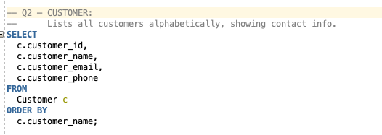
Result of Query 2:

Query 3:
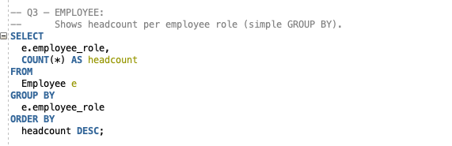
Result from Query 3:
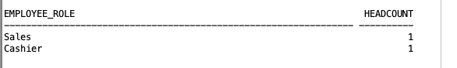

Query 4:
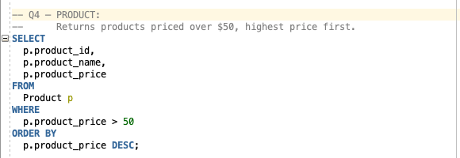
Result from Query 4:

Query 5:
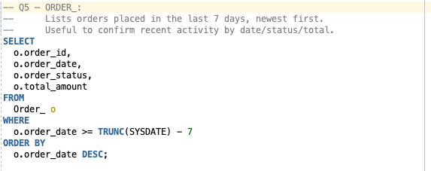
Result from Query 5:
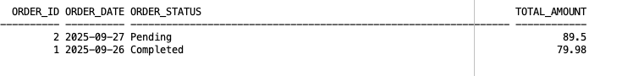

Query 6:
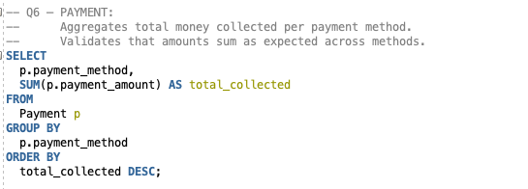
Result from Query 6:
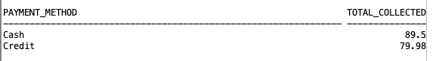

Query 7:
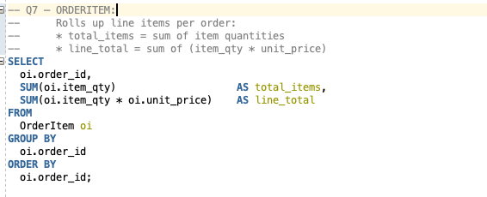
Result from Query 7:
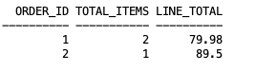

Query 8:
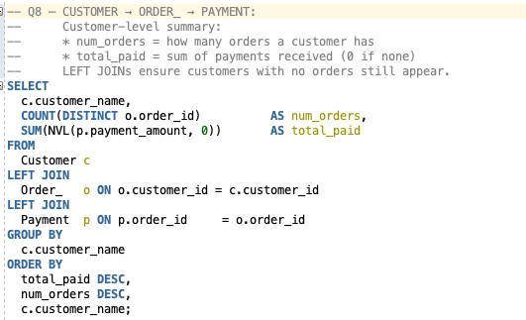
Result from Query 8:

